In order to capture our audience attention and ensure that our website is aesthetically pleasing and legible. We have into a consideration of Tullis’ rules of the formatting of alphanumeric displays.

* **Overall Density:** The website is a centralised site, with sub pages coming in from 4 directions through user interactions. The default page will be clear and simple with minimum texts, only buttons and background will be displayed  
  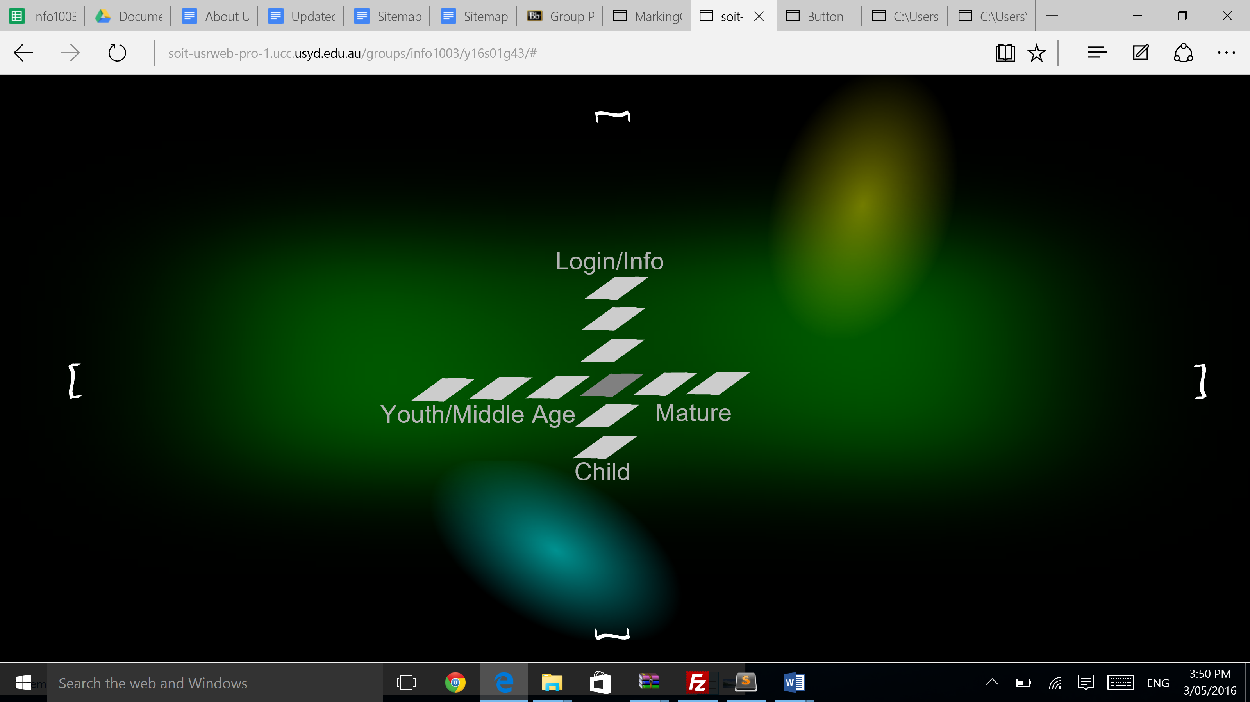  
    
  When each sub-page are displayed, the “wings” will cover 75% of the whole page.The information will be marginalised and displayed within the wing. We aim to format the information to overall cover 30%-40% of the whole page.

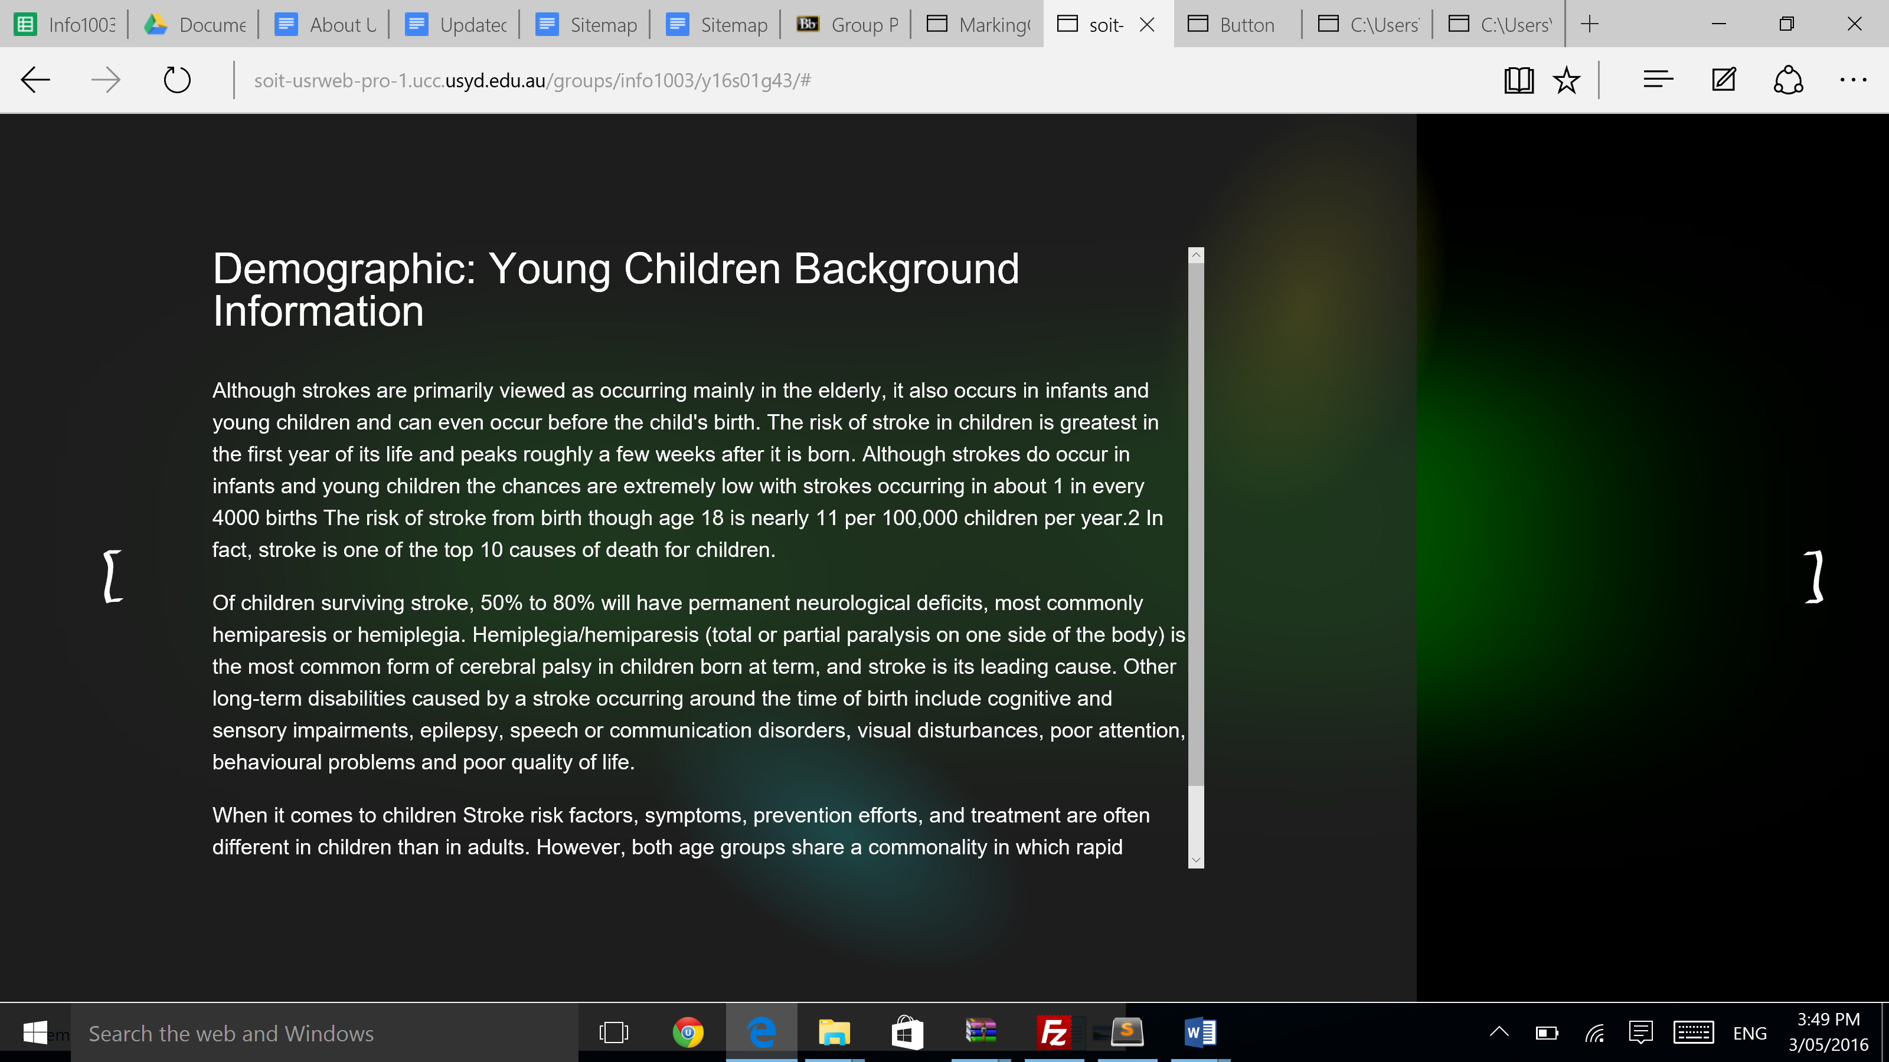

* **Local Density:** The Local Density follows on from overall density as the information will be displayed within the wings, with the information block 30% marginalised as well as in-text spacing and formatting, the local density should not exceed 62%.
* **Grouping:** The website shows strong grouping relationships with the use of wings. With the use of 4-directional design, we have separated informations into 4 main groups mostly according to demographics. Each direction represents:
  + Left: Child
  + Right: Elderly
  + Bottom: Young adults/Middle age
  + Top: Non stroke-related

Each wings will be able to navigate to multiple tiers to find more information about each group.

* **Layout Complexity:** The simplistic and concise design has been our design philosophy throughout the project and we have ensure that our website is easy to use by taking these into considerations:
  + Elimination of all elements that are not of the utmost necessity
  + Strict labeling, titling, and consideration of content in each section
  + Strict uniformity in the style guide for all elements
  + Strict implementation of new content in manners integrating fluidly with directional layout